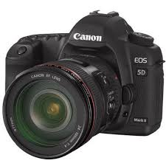
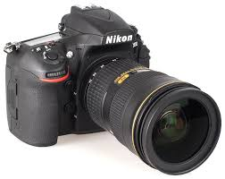

Cost for the 6 week course is £30 per evening or £150 if all booked in advance
www.eclipsephotographic.co.uk
Booking Conditions: -
Any materials or images used remain the property of Eclipse photographic and must not be reproduced in any way. It is accepted that payment of a fee for either the One to One or the Digital Training course is for that purpose only. The course is to operate on a particular date and time and any variation to this will made in writing by email. Any monies paid to Eclipse Photographic will be non-refundable in the event of a cancellation by the participant. If Eclipse Photographic fail to attend on a given date for whatever reason the participant will be entitled to a part refund determined by both parties and rescheduling of the evening if both agree. The deposit payable is £50, with the balance being paid 1 week prior to the commencement date. If the balance is not paid it will be deemed that you do not wish to attend, and your place may be given to another. If you are happy with these booking conditions, please initial here……………………..
Booking Form.
Name ……………………………………………………………………
Address ……………………………………………………………………
Email Address …………………………………………………………………...

Signature …………….……….Date ………………………….

Introduction to Digital Photography

Course’s take place at the offices of Eclipse Photographic, Suite 1, Matthew Temple House, The Broadway (above the book Fayre), Woodhall Spa, LN106ST
- Exposure Modes
Using all the exposure modes on your camera, including ‘why I’m not afraid of manual mode’

- Outdoor Practical Photography

Using your camera in practical sessions to create great images.

- Exposure
Understanding ISO, aperture, and shutter speeds.

- Composition
Learn the basic rules of composition to improve your pictures.

- Light
How to use light, from on camera flash to off camera flash and other light sources.

- Equipment

The use of other equipment to improve your photography.

Topics to include:-
Suite 1, Matthew Temple House, The Broadway, Woodhall Spa, LN106ST, Lincolnshire

